**Vigenère Cipher**

**History**

Invented by: Giovan Battista Bellaso (miscredited to Blaise de Vigenère who in fact made the Autokey cipher)

When: 1553

Why: ????

**Key Generation**

Choose either a sequence of letters or a word.

**Encoding Steps**

For each letter in the key go to the corresponding row on the tabula recta (below (using standard alphabet)) then encode one letter of the plaintext, then move to the next letter of the key. If at the end of the key, repeat the key.

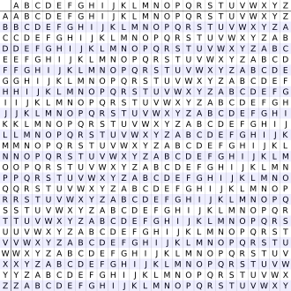

**Decoding Steps**

Do it in reverse order

**Security**

A much more secure cipher you can do by hand, still easily broken on a computer

**Possible Attacks**

### Kasiski examination

1. Friedman test
2. Frequency Analysis (when length of key is known)
3. Key elimination

**Websites Used**

1. <https://en.wikipedia.org/wiki/Vigen%C3%A8re_cipher>